**Laboratorio de Bases de Datos Distribuidas**

**Grupo No.:** 9

**Integrantes:**

* Luis Enrique Pérez Señalin

**Tema: Diseño e Implementación Distribuida (CG)**

Script:  
sp_help estudiante

-- ESQUEMA DE REPLICACION

CREATE DATABASE SIS

GO

USE SIS

CREATE TABLE Facultad (

idfac char(3) not null,

nombre varchar(50) not null,

telef char(10) not null

);

CREATE TABLE Estudiante_Dir (

cc char(10) not null,

dir varchar(50) not null

);

CREATE TABLE Estudiante_SIS (

cc char(10) not null,

numunic char(10) not null,

nombre varchar(50) not null,

apellido varchar(50) not null,

idfac char(3) not null

);

CREATE TABLE Materia_SIS (

idmat char(3) not null,

nommat varchar(50) not null,

horassemana tinyint not null,

idfac char(3) not null

);

CREATE TABLE Matricula_SIS (

cc char(10) not null,

idmat char(3) not null,

idfac char(3) not null,

fechamt date not null,

valorpag numeric(7, 2) not null

);

ALTER TABLE Facultad ADD CONSTRAINT pk_idfac PRIMARY KEY (idfac);

ALTER TABLE Materia_SIS ADD CONSTRAINT pk_idmat PRIMARY KEY (idmat, idfac);

ALTER TABLE Materia_SIS ADD CONSTRAINT fk_idfacmatSIS FOREIGN KEY (idfac) REFERENCES Facultad(idfac);

ALTER TABLE Matricula_SIS ADD CONSTRAINT pk_cc_idmat_idfac PRIMARY KEY (cc, idmat, idfac);

ALTER TABLE Matricula_SIS ADD CONSTRAINT fk_cc_idfac FOREIGN KEY (cc, idfac) REFERENCES Estudiante_SIS(cc, idfac);

ALTER TABLE Matricula_SIS ADD CONSTRAINT fk_idmat_idfac FOREIGN KEY (idmat, idfac) REFERENCES Materia_SIS(idmat, idfac);

ALTER TABLE Estudiante_SIS ADD CONSTRAINT pk_cc_idfac PRIMARY KEY (cc, idfac);

ALTER TABLE Estudiante_SIS ADD CONSTRAINT fk_idfacestSIS FOREIGN KEY (idfac) REFERENCES Facultad(idfac);

-- RECUPERAR DATOS

INSERT INTO SIS.dbo.Facultad

SELECT * FROM Facultades.dbo.Facultad;

INSERT INTO SIS.dbo.Estudiante_Dir

SELECT cc, dir FROM Facultades.dbo.estudiante;

INSERT INTO SIS.dbo.Estudiante_SIS

SELECT cc, numunic, nombre, apellido, idfac FROM Facultades.dbo.estudiante

WHERE idfac = 'SIS';

INSERT INTO SIS.dbo.Materia_SIS

SELECT * FROM Facultades.dbo.materia

WHERE idfac = 'SIS';

INSERT INTO SIS.dbo.Matricula_SIS

SELECT cc, idmat, 'SIS', fechamt, valorpag FROM Facultades.dbo.matricula AS mfac

WHERE (SELECT idfac FROM Facultades.dbo.estudiante AS efac

WHERE mfac.cc = efac.cc) = 'SIS';

SELECT * FROM SIS.dbo.Estudiante_Dir;

SELECT * FROM SIS.dbo.Estudiante_SIS;

SELECT * FROM SIS.dbo.Materia_SIS;

SELECT * FROM SIS.dbo.Matricula_SIS;

SELECT * FROM SIS.dbo.Facultad;

**Capturas:**

Captura de consulta:

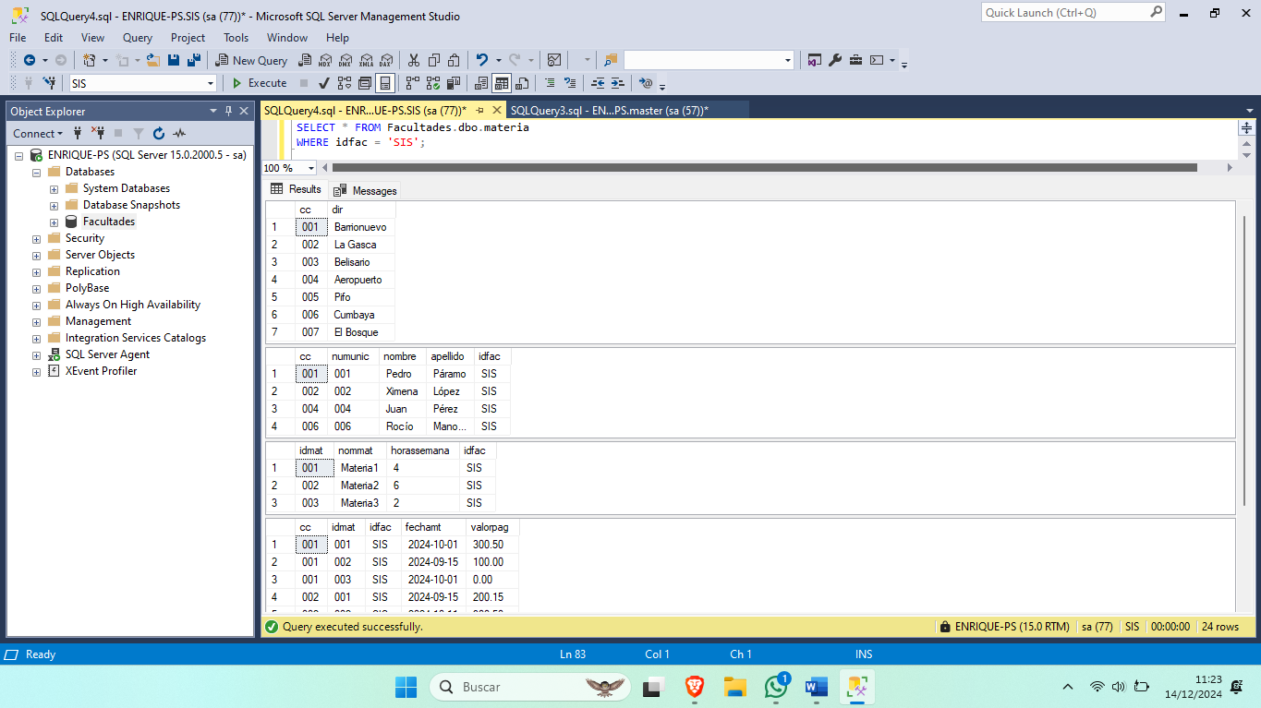

Diagrama:

